**FULL STACK JAVA DEVELOPER CAPSTONE PROJECT**

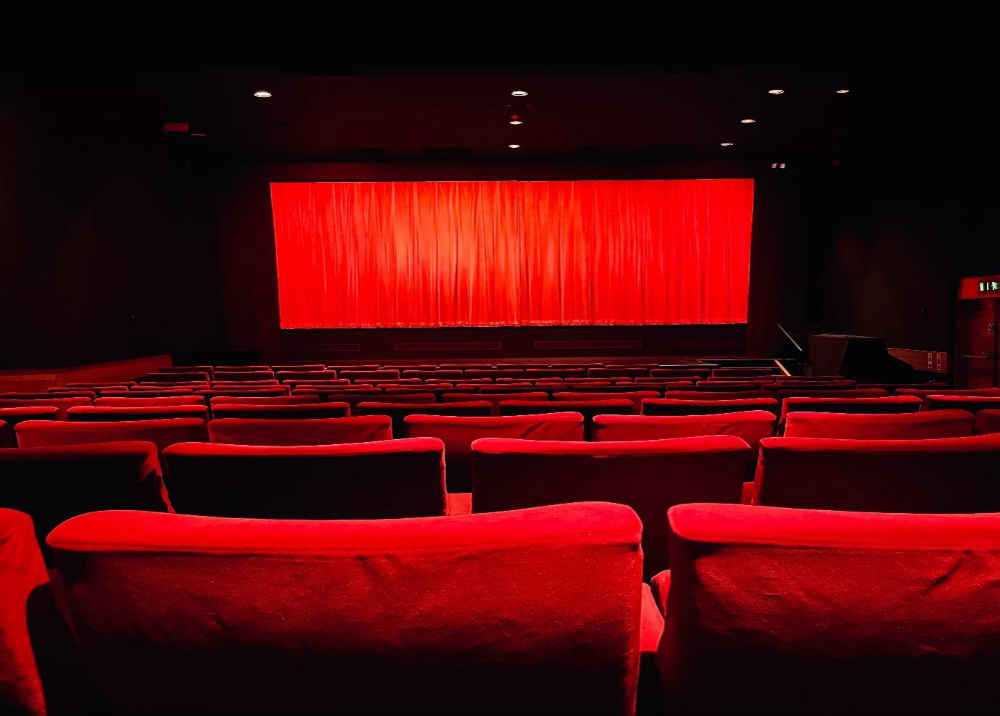

**developer detail**

Application: **MyMoviePlan**

Developer Details: Name: Ankita Tribhuvan

Designation: Full Stack Java Developer

Email Address: ankitatribhuvan6@gmail.com

**Github LINK:**

**https://github.com/Ankita1011T/CAPSTONE-MyMoviePlan/tree/master**

**MyMoviePlan**

**2023**

**Simplilearn Project**

+

+

An online movie ticket booking system facilitates the purchasing of movie tickets to its customers. E-ticketing systems allow customers to browse through movies currently playing and book seats, anywhere and anytime.

**Use Case Diagram**

We have five main Actors in our system:

* **Admin:** Responsible for adding new movies and their shows, canceling any movie or show, blocking/unblocking customers, etc.
* **FrontDeskOfficer:** Can book/cancel tickets.
* **Customer:** Can view movie schedules, and book, and cancel tickets.
* **Guest:** All guests can search for movies but to book seats they have to become registered members.
* **System:** Mainly responsible for sending notifications for new movies, bookings, cancellations, etc.

Here are the top use cases of the Movie Ticket Booking System:

* **Search movies:** To search movies by title, genre, language, release date, and city name.
* **Create/Modify/View booking:** To book a movie show ticket, cancel it or view details about the show.
* **Make payment for booking:** To pay for the booking.
* **Add a coupon to the payment:** To add a discount coupon to the payment.
* **Assign Seat:** Customers will be shown a seat map to let them select seats for their booking.
* **Refund payment:** Upon cancellation, customers will be refunded the payment amount as long as the cancellation occurs within the allowed time frame.

**Here is the use case diagram of the Movie Ticket Booking System**

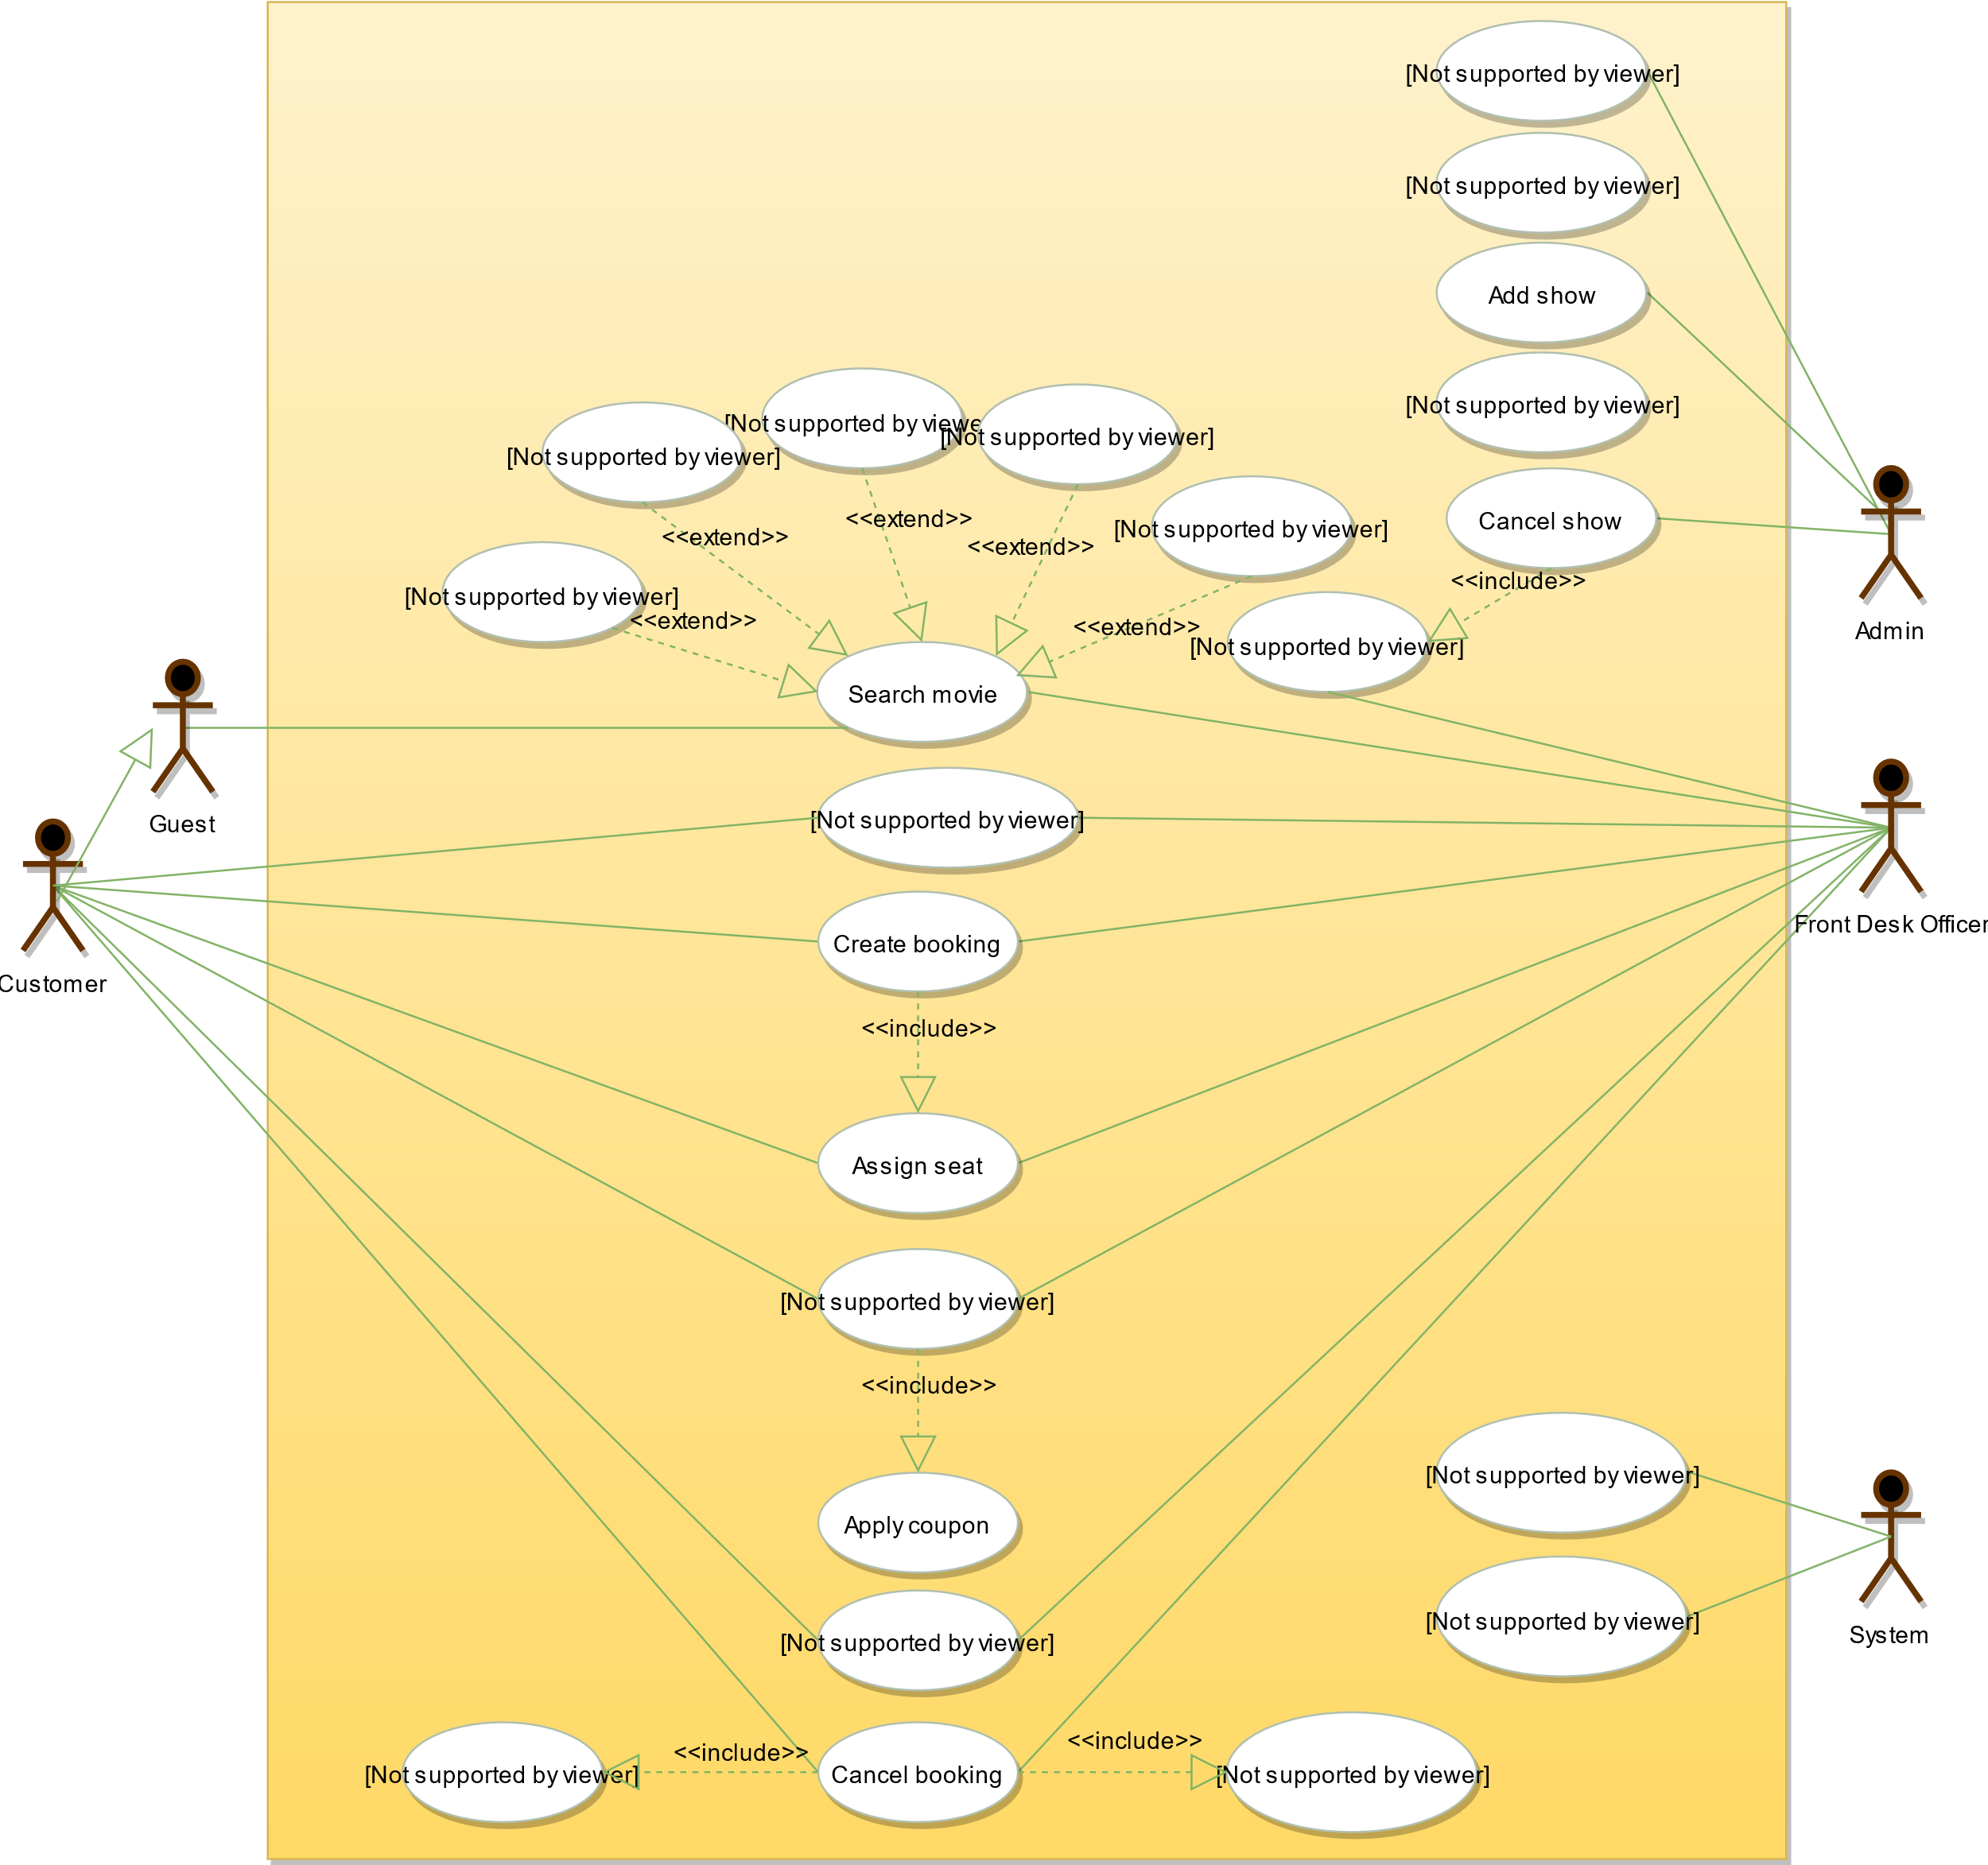

**Class Diagram**

Here are the main classes of the Movie Ticket Booking System:

* **Account:** Admin will be able to add/remove movies and shows, as well as block/unblock accounts. Customers can search for movies and make bookings for shows. FrontDeskOffice can book tickets for movie shows.
* **Guest:** Guests can search and view movies descriptions. To make a booking for a show they have to become a registered member.
* **Cinema:** The main part of the organization for which this software has been designed. It has attributes like ‘name’ to distinguish it from other cinemas.
* **CinemaHall:** Each cinema will have multiple halls containing multiple seats.
* **City:** Each city can have multiple cinemas.
* **Movie:** The main entity of the system. Movies have attributes like title, description, language, genre, release date, city name, etc.
* **Show:** Each movie can have many shows; each show will be played in a cinema hall.
* **CinemaHallSeat:** Each cinema hall will have many seats.
* **ShowSeat:** Each ShowSeat will correspond to a movie Show and a CinemaHallSeat. Customers will make a booking against a ShowSeat.
* **Booking:** A booking is against a movie show and has attributes like a unique booking number, number of seats, and status.
* **Payment:** Responsible for collecting payments from customers.
* **Notification:** Will take care of sending notifications to customers.

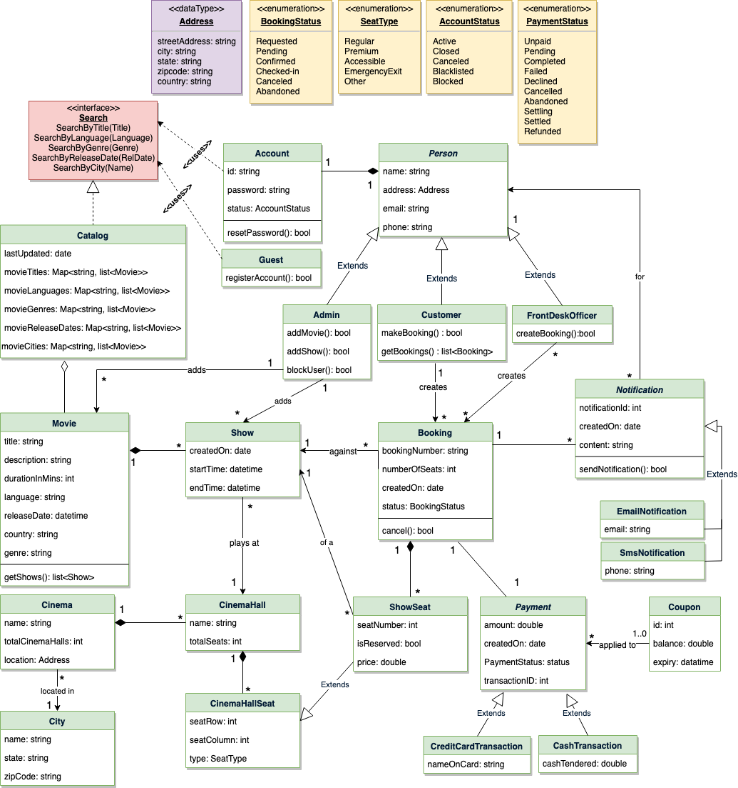

### Activity Diagrams

**Make a booking:** Any customer can perform this activity. Here are the steps to book a ticket for a show:

Activity Diagram for Movie Ticket Booking System Make Booking

**Cancel a booking:** Customer can cancel their bookings. Here are the steps to cancel a booking:

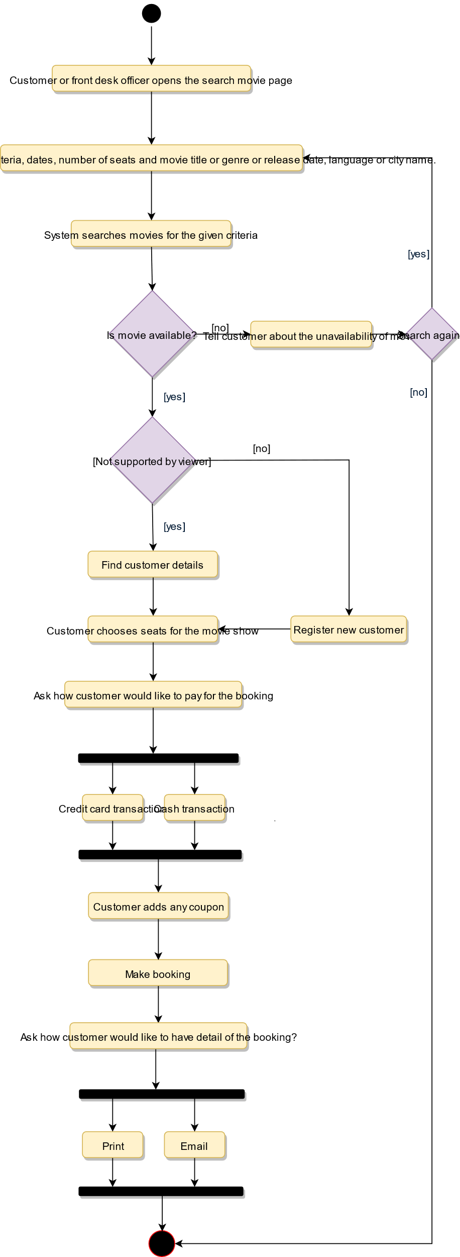

Activity Diagram for Movie Ticket Booking System Make Booking

**Cancel a booking:** Customer can cancel their bookings. Here are the steps to cancel a booking:

